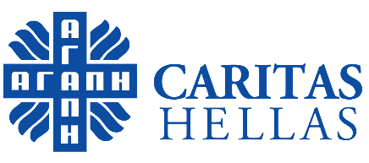
.

Press Release

Photo Exhibition: “My city, Athens…”
Athens, 15-25 September 2022

The Charitable Organization CARITAS informs you that from September 15 to 25 2022, (daily 10.00-12.00 and 18.00-20.00) the photo works of 28 refugees and asylum seekers, aged between 16 and 41, from Syria, Iraq, Afghanistan, Palestine, Algeria, Morocco, Egypt, Ukraine, Pakistan and Ghana will be exhibited at the Catholic Cathedral Basilica of St. Dionysius the Areopagite (Hall A’), in the context of the Photo Exhibition “My city, Athens…”.

CARITAS HELLAS has held a three-month Educational Photography Seminar at its Caritas Social Spot, in Neos Kosmos area, Athens. The Seminar was conducted by the photographer teacher Mr. Yiannis Yiannakopoulos.

The Seminar was part of the “METAVASIS Project - Participation, Empowerment and Social Inclusion of Refugees/Migrants in Greece” concerning the support and integration of refugees and migrants in Greek society, funded by the German Foreign Ministry and CARITAS GERMANY. The ultimate purpose of the Seminar was to help eliminate social exclusion by cultivating social skills in an open environment of creative effort and integration through intercultural education.

The theme that the group was asked to photograph was the city where the refugees and asylum seekers live in; the way they experience their new reality and the way they see the architecture of their city. Through the “clicks”, the “photographers of CARITAS HELLAS” share with us their journey, their own thoughts, pictures, moments, through a journey of knowledge and life in the city, through this tour of images, through the soul of human beings who have traveled from very far away and now they are with us.

We are waiting for you!

Information
Group Photography Exhibition: “My city, Athens…”
Exhibition Period: 15-25 September 2022
Celebration for the World Day of Migrants & Refugees: Sunday, 25 September 2022, 12:00
Operating Hours: Daily: 10.00-12.00 & 18.00-20.00
Location: Catholic Cathedral Basilica of St. Dionysius the Areopagite (Hall A’)

Free Entrance

